**ASSIGNMENT-4**

|  |  |
| --- | --- |
| Date | 10November2022 |
| TeamID | PNT2022TMID06176 |
| Project name | Gas leakage monitoring & Alerting System for Industries |

# **Question1:**

Write code and connections in work for ultrasonic sensor. Whenever distance is less than 100cms send "alert" to IBM cloud and display in device recent events.

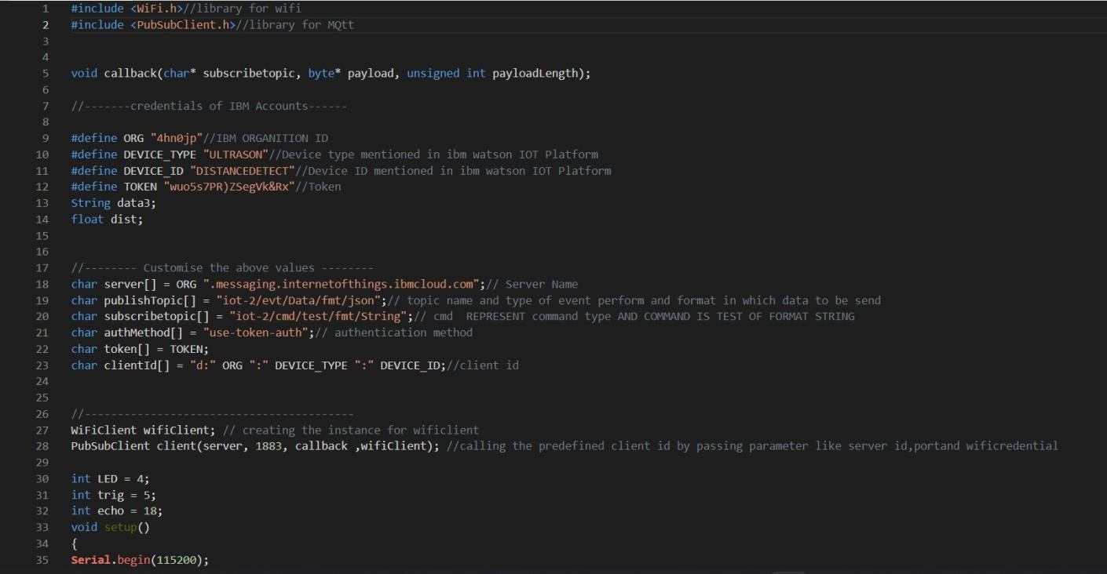**CODE**:

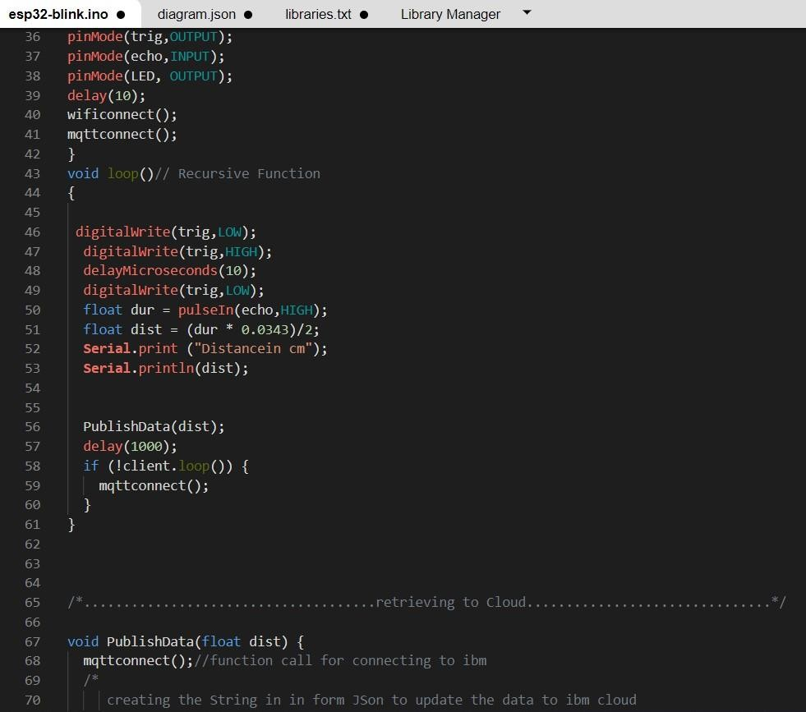

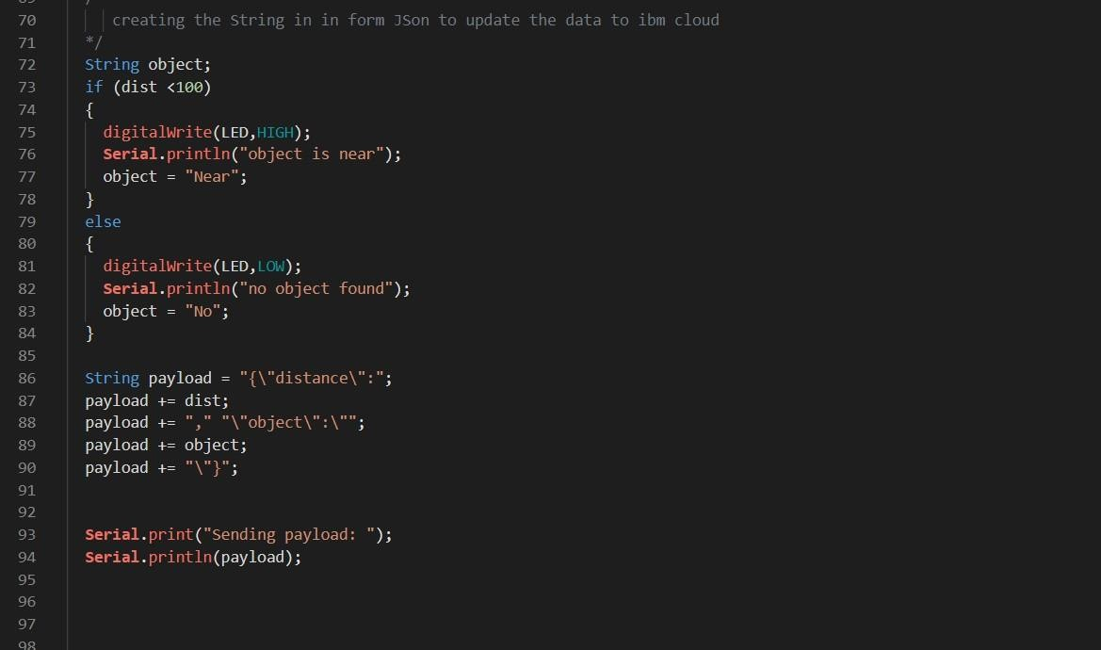

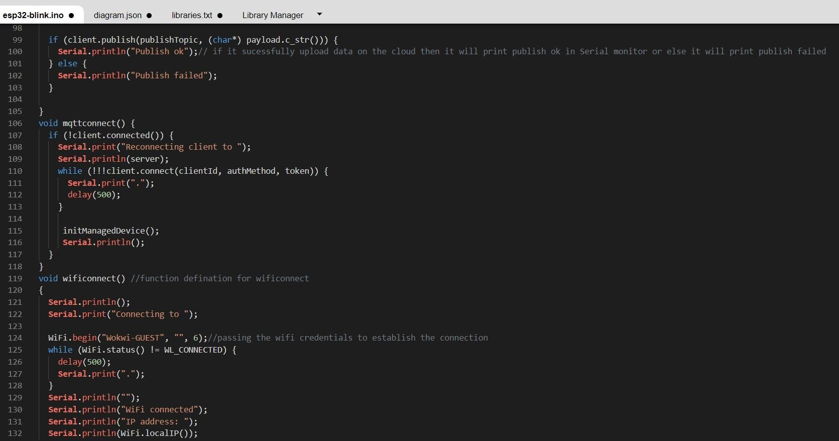

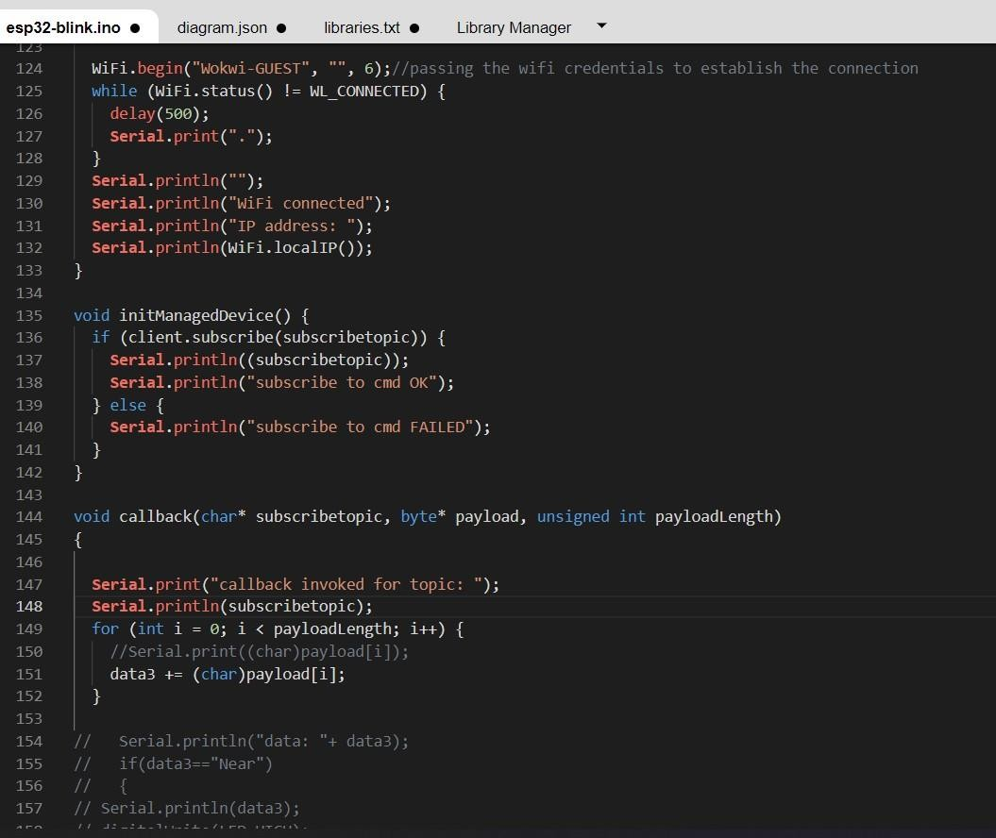

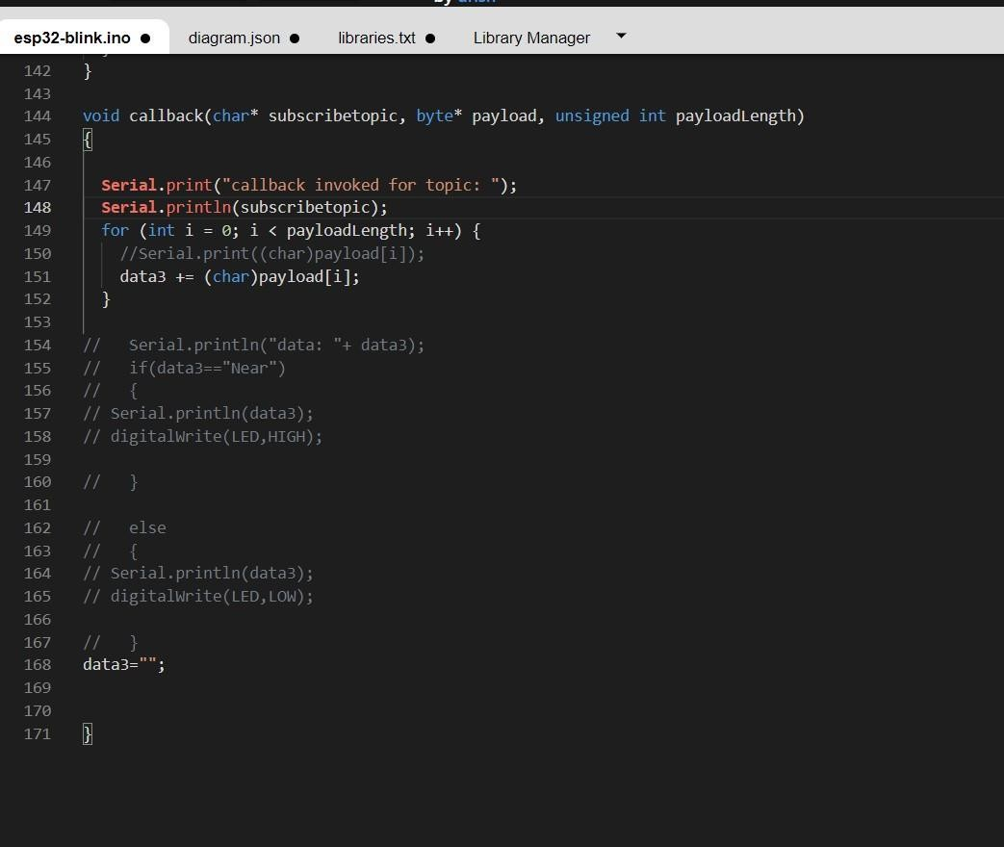

# **OUTPUT**:

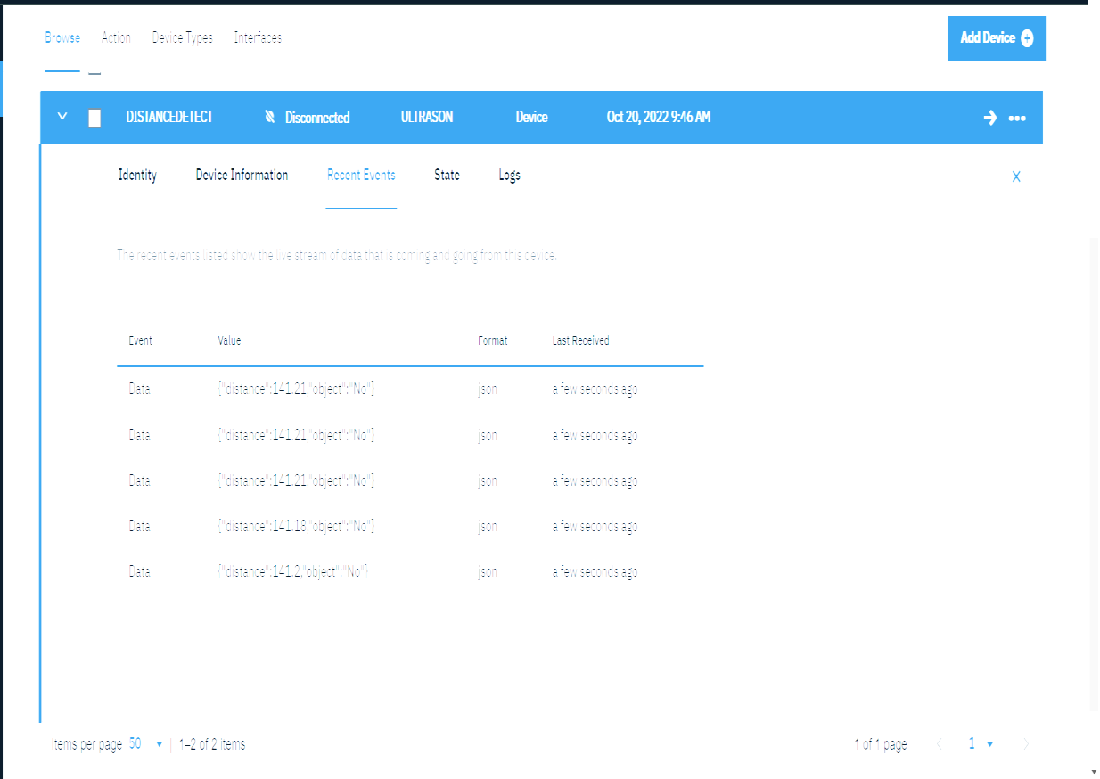Data send to the IBMcloud device when the objectis far

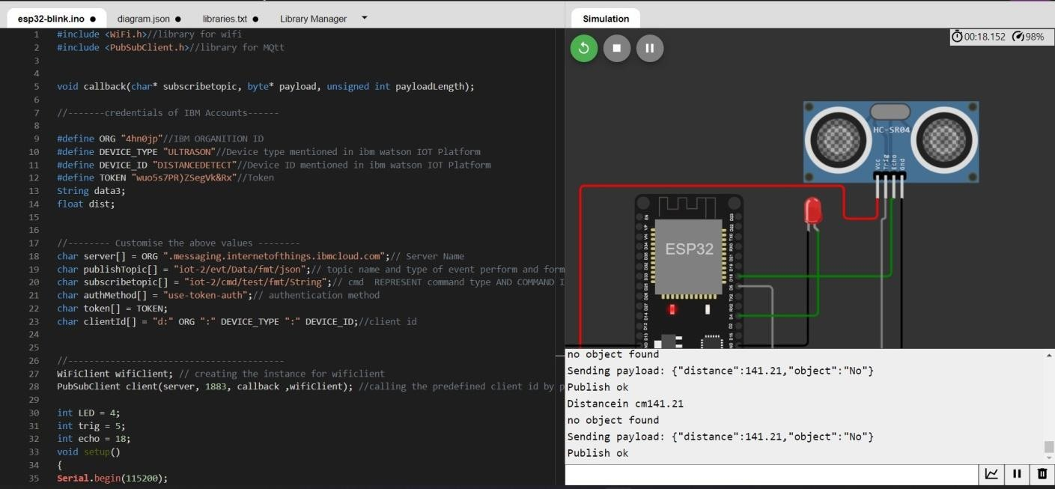

Data sent to the IBMCloud Device when the object is near

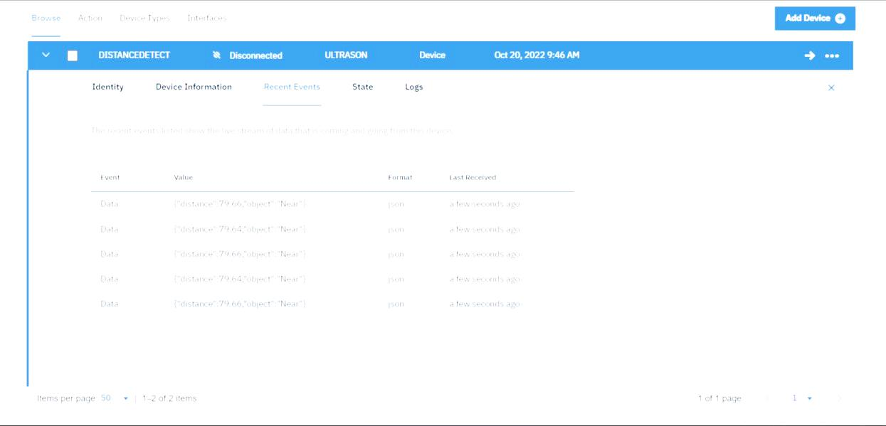­­

# 

# When object is near to the ultrasonicsensor